1

**CHAPTER 1**

INTRODUCTION

Under water environment offers many rare attractions such as marine animals and fishes, amazing landscape, and mysterious shipwrecks. Besides underwater photography, underwater imaging has also been an important source of interest in different branches of technology and scientific research [1] such as inspection of underwater infrastructures [2] and cables [3], detection of manmade objects [4], control of underwater vehicles [5], marine biology research [6], and archaeology [7]. Different from common images, underwater images suffer from poor visibility resulting from the attenuation of the propagated light, mainly due to absorption and scattering effects. The absorption substantially reduces the light energy, while the scattering causes changes in the light propagation direction. They result in foggy appearance and contrast degradation making distant objects misty. Practically, in common sea water images, the objects at a distance of more than 10 meters are almost unperceivable, and the colors are faded because their composing wavelengths are cut according to the water depth.

* 1. **what is Underwater Image Enhancement**

Image enhancement is a process of improving the quality of imag**e** by improving its feature. The underwater image suffers from low contrast and resolution, due to Light Scattering and color change. Underwater images are of poor quality and are blurred . Underwater image enhancement reduces the blurriness of the image and enhance the quality of underwater images through image enhancement techniques.

2

* 1. **Applications of Underwater Image Enhancement**

Underwater imaging has some recent applications such as fish-pond monitor , bed-sediment microscope, hand-held stereocam, fix error concrete columns and fix dams.

Underwater imaging has a wide range of applications like to study fishes, to study about coral reefs, to study about seafloor hydro thermal vents. Underwater Imaging Enhancement is important for research area and technology in ocean engineering. Underwater haze removal techniques become very important due to the use of no. of vision underwater applications. scientists are very keen to explore the mysterious underwater world. Haze in the Image brings trouble to many computer vision/graphics applications as it degrades the visibility of the scene and Image Quality. Haze is formed due to the attenuation and the air light. Attenuation reduces the contrast and air light increases the whiteness in the scene. Underwater imaging removes the haze in the images. We found our technique to be suitable for computer vision applications.

Segmentation aims at dividing images into disjoint and homogeneous regions with respect to some characteristics (e.g. texture, color). In this work, we employ the G AC + + segmentation algorithm [71], which corresponds to a seminal geodesic active contours method (variational PDE). Fig. 15 shows that the segmentation result is more consistent when segmentation is applied to images that have been processed by our approach.

3

* 1. **Literature Survey**

Underwater imaging has also been an important source of interest in different branches of technology and scientific research [1] such as inspection of underwater infrastructures [2] and cables [3], detection of manmade objects [4], control of underwater vehicles [5], marine biology research [6], and archeology [7].

The deterioration of underwater scenes results from the combination of multiplicative and additive processes [8] traditional enhancing techniques such as gamma correction, histogram equalization appear to be strongly limited for such a task. In the previous works that are surveyed in Section II.B, the problem has been tackled by tailored acquisition strategies using multiple images [9] specialized hardware [10] or polarization filters [11].

The comprehensive studies of McGlamery [12] and Jaffe [13] have shown that the total irradiance incident on a generic point of the image plane has three main components in underwater mediums: direct component, forward scattering and back scattering.

The existing underwater dehazing techniques can be grouped in several classes. An important class corresponds to the methods using specialized hardware [1], [10], [15]. For instance, the divergent-beam underwater Lidar imaging (UWLI) system [10] uses an optical/laser-sensing technique to capture turbid underwater images.

A third class of approaches employs multiple images [9], [16] or a rough approximation of the scene model [17]. Narasimhan and Nayar [9] exploited changes in intensities of scene points under different weather conditions in order to detect depth discontinuities in the scene. Deep Photo system [17] is able to restore images by employing the existing geo referenced digital terrain and urban 3D models.

Recently, several single image dehazing techniques have been introduced to restore images of outdoor foggy scenes [18]–[23]. These dehazing techniques reconstruct the intrinsic brightness of objects by inverting the Koschmieder’s visibility model [14].

4

These dehazing techniques reconstruct the intrinsic brightness of objects by inverting the Koschmieder’s visibility model [14]. Despite this model was initially formulated under strict assumptions (e.g. homogeneous atmosphere illumination, unique extinction coefficient whatever the light wavelength, and space-uniform scattering process) [24], several works have relaxed those strict constraints, and have shown that it can be used in heterogeneous lightning conditions and with heterogeneous extinction coefficient as long as the model parameters are estimated locally [20], [21], [25].

In the underwater context, the approach of Chiang and Chen [27] segments the foreground and the background regions based on DCP, and uses this information to remove the haze and color variations based on color compensation. Drews, Jr., et al. [28] also build on DCP, and assume that the predominant source of visual information under the water lies in the blue and green color channels. Their Underwater Dark Channel Prior (UDCP) has been shown to estimate better the transmission of underwater scenes than the conventional DCP. Galdran et al. [29] observe that, under water, the red component reciprocal increases with the distance to the camera, and introduce the Red Channel prior to recover colors associated with short wavelengths in underwater. Emberton et al. [30] .Lu et al. [31]. employ color lines, as in [32], to estimate the ambient light, and implement a variant of the DCP to estimate the transmission.

Very recently, [31] has been extended to increase the resolution of its de scattered and color-corrected output. This extension is presented in [33] and builds on super resolution from transformed self-exemplars [34] to derive two high-resolution (HR) images, respectively from the output derived in [31] and from a de noised/de scattered version of this output.

Specialized underwater image enhancing techniques have been introduced [36]–[38], based on the extension of the traditional enhancing techniques that are found in commercial tools such as color correction, histogram equalization/stretching, and linear mapping. Within this class, Chambah et al. [39] designed an unsupervised color correction strategy, Arnold-Bos et al. [37] developed a framework to deal with specific underwater noise, while the technique of Petit et al. [38] restores the image contrast by inverting a light attenuation model after applying a color space contraction.

5

The Gray world algorithm [43] assumes that the average reflectance in the scene is achromatic. Hence, the illuminant color distribution is simply estimated by averaging each channel independently. The Max RGB [42] assumes that the maximum response in each channel is caused by a white patch [44], and consequently estimates the color of the light source by employing the maximum response of the different color channels.

In contrast, by simply applying DCP on our white balanced image version we obtain comparable and even better estimates than the specialized underwater techniques of UDCP [49], MDCP [50] and BP [51]..In this work we built on the multi-scale fusion principles to propose a single image underwater dehazing solution. Image fusion has shown utility in several applications such as image compositing [52], multispectral video enhancement [53], defogging [23], [54] and HDR imaging [55].

Laplacian contrast weight (WL ) estimates the global contrast by computing the absolute value of a Laplacian filter applied on each input luminance channel. This straightforward indicator was used in different applications such as tone mapping [55] and extending depth of field [57] since it assigns high values to edges and texture.

The associated quantitative evaluation, using three recent metrics: PCQI [64], UCIQE [65], and UIQM [66]. While PCQI is a general-purpose image contrast metric, the UCIQE and UIQM metrics are dedicated to underwater image assessment.

**6**

**1.4 Disadvantages of Existing Methods**

There have been several attempts to restore and enhance the visibility of degraded images. Since the deterioration of underwater scenes results from the combination of multiplicative and additive processes traditional enhancing techniques such as gamma correction, histogram equalization appear to be strongly limited for such a task. In the previous works that are surveyed in Section II.B, the problem has been tackled by tailored acquisition strategies using multiple images [9]specialized hardware [10] or polarization filters [11]. Despite of their valuable achievements, these strategies suffer from a number of issues that reduce their practical applicability.

Histogram Equalization is computationally very slow and it requires high number of operations per pixel. If they are grey values that are physically apart from each other in the image. Have problems with histogram which covers all grey values. Requires a few more operations because it is necessary to create cumulative. Better suited to independent hardware implementation.

Most gamma correction images have limited precision , and hence multiple input values may map to the same output and vice-versa. Linear color space is also not perceptually uniform.

7

* 1. **Objectives of Current Method**

The paper is structured as follows. The next section briefly surveys the optical specificities of the underwater environment, before summarizing the work related to underwater dehazing. In Section III, we present our novel white-balancing approach, especially designed for underwater images. Section IV then describes the main components of our fusion-based enhancing technique, including inputs and associated weight maps definition. Before concluding, we present comparative qualitative and quantitative assessments of our white-balancing and fusion-based underwater dehazing techniques, as well as some results about their relevance to address common computer vision problems, namely image segmentation and feature matching.

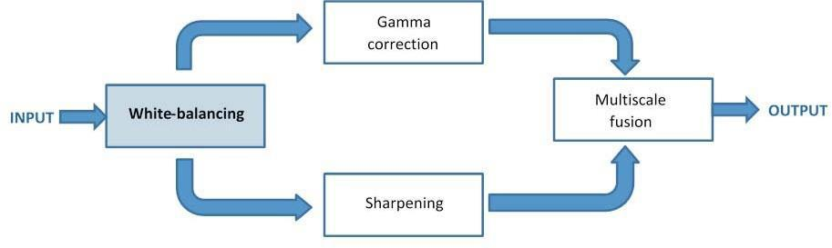

Fig . 1 Method overview: two images are derived from a white-balanced version of the single input, and are merged based on a (standard) multi scale fusion algorithm. the novelty of our approach lies in the proposed pipeline, but also in the definition of a white-balancing algorithm that is suited to our underwater enhancement problem.



8

* 1. **Scope of Current Methods**

Our validation also proves that our algorithm is reasonably independent of the camera settings, and improves the accuracy of several image processing applications, such as image segmentation and key point matching.

The proposed strategy was tested for real underwater image and videos taken from different available amateur and professional photographer collections, captured using various cameras and setups. Note that we process only 8-bit data format, making our validation relevant for common low-end cameras. For videos, the reader is referred to Fig. 12. Interestingly, our fusion based algorithm has the advantage to employ only a reduced set of parameters that can be automatically set. Specifically, the white balancing process relies on the single parameter α, which is set to 1 in all our experiments.

9

**CHAPTER-2**

EXISTING METHODS

2.1 **Overview of Existing Methods**

This section surveys the basic principles underlying light propagation in water, and reviews the main approaches that have been considered to restore or enhance the images captured under water.

**A. Light Propagation in Underwater**

For an ideal transmission medium the received light is influenced mainly by the properties of the target objects and the camera lens characteristics. This is not the case underwater. First, the amount of light available under water, depends on several factors. The interaction between the sun light and the sea surface is affected by the time of the day (which influences the light incidence angle), and by the shape of the interface between air and water (rough vs. calm sea). The diving location also directly impacts the available light, due to a location-specific color cast: deeper seas and oceans induce green and blue casts, tropical waters appear cyan, while protected reefs are characterized by high visibility. In addition to the variable amount of light available under water, the density of particles that the light has to go through is several hundreds of times denser in seawater than in normal atmosphere. As a consequence, sub-sea water absorbs gradually different wavelengths of light. Red, which corresponds to the longest wavelength, is the first to be absorbed (10-15 ft), followed by orange (20-25 ft), and yellow (35-45 ft). Pictures taken at 5 ft depth will have a noticeable loss of red. Furthermore, the refractive index of water makes judging distances difficult. As a result, underwater objects can appear 25% larger than they really are. The comprehensive studies of McGlamery [12] and Jaffe [13] have shown that the total irradiance incident on a generic point of the image plane has three main components in underwater mediums: direct component, forward scattering and back scattering. The direct component is the component of light reflected directly by the target object onto the image plane.

10

At each image coordinate x the direct component is expressed as:

ED(x) = J (x)e−ηd(x) = J (x)t(x) (1)

where J (x) is the radiance of the object, d(x) is the distance between the observer and the object, and η is the attenuation coefficient. The exponential term e−ηd(x) is also known as the transmission t(x) through the underwater medium. Besides the absorption, the floating particles existing in the underwater mediums also cause the deviation (scattering) of the incident rays of light. Forward

-scattering results from a random deviation of a light ray on its way to the camera lens. It has been determined experimentally that its impact can be approximated by the convolution between the direct attenuated component, with a point spread function that depends on the distance between the image plane and the object. Back-scattering is due to the artificial light (e.g. flash) that hits the water particles, and is reflected back to the camera. Back-scattering acts like a glaring veil superimposed on the object. The influence of this component may be reduced significantly by simply changing the position and angle of the artificial light source so that most of the reflected particle light do not reach the camera. However, in many practical cases, back-scattering remains the principal source of contrast loss and color shifting in underwater images. Mathematically, it is often expressed as:

EBS(x) = B∞(x)(1 − e−ηd(x) ) (2)

where B∞(x) is a color vector known as the back-scattered light. Ignoring the forward scattering component, the simplified underwater optical thus becomes:

I(x) = J (x)e−ηd(x) + B∞(x)(1 − e−ηd(x) ) (3)

This simplified underwater camera model (3) has a similar form than the model of Koschmieder [14], used to characterize the propagation of light in the atmosphere. It however does not reflect the fact that the attenuation coefficient strongly depends on the light wavelength, and thus the color, in underwater environments. Therefore, as discussed in the next section and illustrated in Fig. 11, a straightforward extension of outdoor dehazing approaches performs poorly at great depth, in presence of non-uniform artificial illumination and selective absorption of colors. This is also why our approach does not resort to an explicit inversion of the light propagation model.

11

**2.1 RELATED WORK**

The existing underwater dehazing techniques can be grouped in several classes. An important class corresponds to the methods using specialized hardware [1], [10], [15]. For instance, the divergent-beam underwater Lidar imaging (UWLI) system [10] uses an optical/laser-sensing technique to capture turbid underwater images. Unfortunately, these complex acquisition systems are very expensive, and power consuming.

A second class consists in polarization-based methods. These approaches use several images of the same scene captured with different degrees of polarization, as obtained by rotating a polarizing filter fixed to the camera. For instance, Schechner and Averbuch [11] exploit the polarization associated to back-scattered light to estimate the transmission map. While being effective in recovering distant regions, the polarization techniques are not applicable to video acquisition, and are therefore of limited help when dealing with dynamic scenes.

A third class of approaches employs multiple images [9], [16] or a rough approximation of the scene model [17]. Narasimhan and Nayar [9] exploited changes in intensities of scene points under different weather conditions in order to detect depth discontinuities in the scene. Deep Photo system [17] is able to restore images by employing the existing geo referenced digital terrain and urban 3D models. Since this additional information (images and depth approximation) is generally not available, these methods are impractical for common users.

A fourth class of methods exploits the similarities between light propagation in fog and under water. Recently, several single image dehazing techniques have been introduced to restore images of outdoor foggy scenes [18]–[23]. These dehazing techniques reconstruct the intrinsic brightness of objects by inverting the Koschmieder’s visibility model [14]. Despite this model was initially formulated under strict assumptions (e.g. homogeneous atmosphere illumination, unique extinction coefficient whatever the light wavelength, and space-uniform scattering process) [24],

12

underwater imaging is even more challenging, due to the fact that the extinction resulting from scattering depends on the light wavelength, i.e. on the color component.

Recently, several algorithms that specifically restoreunderwater images

based on Dark Channel Prior (DCP) have been introduced. The DCP has initially been proposed for outdoor scenes dehazing. It assumes that the radiance of an object in a natural scene is small in at least one of the color component, and consequently defines regions of small transmission as the ones with large minimal value of colors. In the underwater context, the approach of Chiang and Chen [27] segments the foreground and the background regions based on DCP, and uses this information to remove the haze and color variations based on color compensation. Drews, Jr., et al. [28] also build on DCP, and assume that the predominant source of visual information under the water lies in the blue and green color channels. Their Underwater Dark Channel Prior (UDCP) has been shown to estimate better the transmission of underwater scenes than the conventional DCP. Galdran et al. [29] observe that, under water, the red component reciprocal increases with the distance to the camera, and introduce the Red Channel prior to recover colors associated with short wavelengths in underwater. Emberton et al. [30] designed a hierarchical rank based method, using a set of features to find those image regions that are the most haze-opaque, thereby refining the back-scattered light estimation, which in turns improves the light transmission model inversion.

Lu et al. [31]. employ color lines, as in [32], to estimate the ambient light, and implement a variant of the DCP to estimate the transmission. As additional worthwhile contributions, bilateral filter is considered to remove highlighted regions before ambient light estimation, and another locally adaptive filter is considered to refine the transmission. Very recently, [31] has been extended to increase the resolution of its de scattered and color-corrected output. This extension is presented in [33] and builds on super resolution from transformed self-exemplars [34] to derive two high-resolution (HR) images, respectively from the output derived in [31] and from a de noised/de scattered version of this output. A fusion-based strategy is then considered to blend those two intermediate HR images.

13

In contrast, our approach fundamentally aims at improving the colors (white balancing component in Fig. 1), and uses the fusion to reinforce the edges (sharpening block in Fig. 1) and the color contrast (Gamma correction in Fig. 1). Actually, our solution provides an alternative to [31], while the HR fusion introduced in [33] should be considered as an optional complement to our work, to be applied to the output of our method when high resolution is desired.

An initial version of our fusion-based approach had been presented in our IEEE CVPR conference paper [35]. Compared to this preliminary work, this journal paper proposes a novel white balancing strategy that is shown to outperform our initial solution in presence of severe light attenuation, while supporting accurate transmission estimation in various acquisition settings. Our journal paper also revises the practical implementation of the fusion approach by proposing an alternative and simplified definition of the inputs and associated weight maps. results reveal that our proposed dehazing strategy also improves the accuracy of conventional segmentation and point-matching algorithms (Section V.C), making our dehazing relevant for automatic underwater image processing systems.

To conclude this survey, it is worth mentioning that a class of specialized underwater image enhancing techniques have been introduced [36]–[38], based on the extension of the traditional enhancing techniques that are found in commercial tools such as color correction, histogram equalization/stretching, and linear mapping. Within this class, Chambah et al. [39] designed an unsupervised color correction strategy, Arnold-Bos et al. [37] developed a framework to deal with specific underwater noise, while the technique of Petit et al. [38] restores the image contrast by inverting a light attenuation model after applying a color space contraction. These approaches however appear to be effective only for relatively well illuminated scenes, and generally introduce strong halos and color distortions in presence of relatively poor lightning conditions.

14

**2.2 Histogram Equalization**

This method usually increases the global contrast of many images, especially when the usable data of the image is represented by close contrast values. Through this adjustment, the intensities can be better distributed on the histogram. This allows for areas of lower local contrast to gain a higher contrast. Histogram equalization accomplishes this by effectively spreading out the most frequent intensity values.

The method is useful in images with backgrounds and foregrounds that are both bright or both dark. In particular, the method can lead to better views of bone structure in x-ray images, and to better detail in photographs that are over or under-exposed. A key advantage of the method is that it is a fairly straightforward technique and an invertible operator. So in theory, if the histogram equalization function is known, then the original histogram can be recovered. The calculation is not computationally intensive. A disadvantage of the method is that it is indiscriminate. It may increase the contrast of background noise, while decreasing the usable signal.

In scientific imaging where spatial correlation is more important than intensity of signal (such as separating DNA fragments of quantized length), the small signal to noise ratio usually hampers visual detection.

Histogram equalization often produces unrealistic effects in photographs; however it is very useful for scientific images like thermal, satellite or x-ray images, often the same class of images to which one would apply false-color. Also histogram equalization can produce undesirable effects (like visible image gradient) when applied to images with low color depth. For example, if applied to 8-bit image displayed with 8-bit gray-scale palette it will further reduce color depth (number of unique shades of gray) of the image. Histogram equalization will work the best when applied to images with much higher color depth than palette size, like continuous data or 16-bit gray-scale images.

There are two ways to think about and implement histogram equalization, either as image change or as palette change. The operation can be expressed as *P(M(I))* where *I* is the original image, *M* is histogram equalization mapping operation and *P* is a palette.

15

Modifications of this method use multiple histograms, called subhistograms, to emphasize local contrast, rather than overall contrast. Examples of such methods include adaptive histogram equalization, *contrast limiting adaptive histogram equalization* or CLAHE, multipeak histogram equalization (MPHE), and multipurpose beta optimized bihistogram equalization (MBOBHE). The goal of these methods, especially MBOBHE, is to improve the contrast without producing brightness mean-shift and detail loss artifacts by modifying the HE algorithm.[[1]](https://en.wikipedia.org/wiki/Histogram_equalization#cite_note-1)

A signal transform equivalent to histogram equalization also seems to happen in biological neural networks so as to maximize the output firing rate of the neuron as a function of the input statistics. This has been proved in particular in the fly retina.[[2]](https://en.wikipedia.org/wiki/Histogram_equalization#cite_note-2)

Histogram equalization is a specific case of the more general class of histogram remapping methods. These methods seek to adjust the image to make it easier to analyze or improve visual quality (e.g., retinex).

**Back Projection-**

The back projection (or "project") of a histogrammed image is the re-application of the modified histogram to the original image, functioning as a look-up table for pixel brightness values.

For each group of pixels taken from the same position from all input single-channel images, the function puts the histogram bin value to the destination image, where the coordinates of the bin are determined by the values of pixels in this input group. In terms of statistics, the value of each output image pixel characterizes the probability that the corresponding input pixel group belongs to the object whose histogram is used.[[3]](https://en.wikipedia.org/wiki/Histogram_equalization#cite_note-3)

16

**2.3 Gamma Correction**

Gamma encoding of images is used to optimize the usage of bits when encoding an image, or bandwidth used to transport an image, by taking advantage of the non-linear manner in which humans perceive light and color. The human perception of brightness, under common illumination conditions (not pitch black nor blindingly bright), follows an approximate power function (note: no relation to the gamma function), with greater sensitivity to relative differences between darker tones than between lighter ones, consistent with the Stevens' power law for brightness perception. If images are not gamma-encoded, they allocate too many bits or too much bandwidth to highlights that humans cannot differentiate, and too few bits or too little bandwidth to shadow values that humans are sensitive to and would require more bits/bandwidth to maintain the same visual quality.Gamma encoding of floating-point images is not required (and may be counterproductive), because the floating-point format already provides a piecewise linear approximation of a logarithmic curve.

Although gamma encoding was developed originally to compensate for the input–output characteristic of cathode ray tube (CRT) displays, that is not its main purpose or advantage in modern systems. In CRT displays, the light intensity varies nonlinearly with the electron-gun voltage. Altering the input signal by gamma compression can cancel this nonlinearity, such that the output picture has the intended luminance. However, the gamma characteristics of the display device do not play a factor in the gamma encoding of images and video—they need gamma encoding to maximize the visual quality of the signal, regardless of the gamma characteristics of the display device. The similarity of CRT physics to the inverse of gamma encoding needed for video transmission was a combination of coincidence and engineering, which simplified the electronics in early television sets.

17

**Methods to perform gamma correction in computing**

Up to four elements can be manipulated in order to achieve gamma encoding to correct the image to be shown on a typical 2.2- or 1.8-gamma computer display:

* The pixel's intensity values in a given image file; that is, the binary pixel values are stored in the file in such way that they represent the light intensity via gamma-compressed values instead of a linear encoding. This is done systematically with digital video files (as those in a DVD movie), in order to minimize the gamma-decoding step while playing, and maximize image quality for the given storage. Similarly, pixel values in standard image file formats are usually gamma-compensated, either for sRGB gamma (or equivalent, an approximation of typical of legacy monitor gammas), or according to some gamma specified by metadata such as an ICC profile. If the encoding gamma does not match the reproduction system's gamma, further correction may be done, either on display or to create a modified image file with a different profile.
* The rendering software writes gamma-encoded pixel binary values directly to the video memory(when highcolor/truecolor modes are used) or in the CLUT hardware registers (when indexed color modes are used) of the display adapter. They drive Digital-to-Analog Convertors (DAC) which output the proportional voltages to the display. For example, when using 24-bit RGB color (8 bits per channel), writing a value of 128 (rounded midpoint of the 0–255 byte range) in video memory it outputs the proportional ≈ 0.5 voltage to the display, which it is shown darker due to the monitor behavior. Alternatively, to achieve ≈ 50% intensity, a gamma-encoded look-up table can be applied to write a value near to 187 instead of 128 by the rendering software.
* Modern display adapters have dedicated calibrating CLUTs, which can be loaded once with the appropriate gamma-correction look-up table in order to modify the encoded signals digitally before the DACs that output voltages to the monitor. Setting up these tables to be correct is called hardware calibration.

18

* Some modern monitors allow the user to manipulate their gamma behavior (as if it were merely another brightness/contrast-like setting), encoding the input signals by themselves before they are displayed on screen. This is also a calibration by hardware technique but it is performed on the analog electric signals instead of remapping the digital values, as in the previous cases.

In a correctly calibrated system, each component will have a specified gamma for its input and/or output encodings. Stages may change the gamma to correct for different requirements, and finally the output device will do gamma decoding or correction as needed, to get to a linear intensity domain. All the encoding and correction methods can be arbitrarily superimposed, without mutual knowledge of this fact among the different elements; if done incorrectly, these conversions can lead to highly distorted results, but if done correctly as dictated by standards and conventions will lead to a properly functioning system.

In a typical system, for example from camera through JPEG file to display, the role of gamma correction will involve several cooperating parts. The camera encodes its rendered image into the JPEG file using one of the standard gamma values such as 2.2, for storage and transmission. The display computer may use a color management engine to convert to a different color space (such as older Macintosh's *γ* = 1.8color space) before putting pixel values into its video memory. The monitor may do its own gamma correction to match the CRT gamma to that used by the video system. Coordinating the components via standard interfaces with default standard gamma values makes it possible to get such system properly configured.

19

**2.4 Summary**

Histogram Equalization is a method in image processing of contrast adjustment using the image’s histogram. Histogram Equalization offers an excellent enhancement of image contrast. Histogram Equalization is very easy to implement. But, Histogram Equalization is computationally very slow.

Histogram Equalization requires high number of operations per pixel.

Gamma Correction adjust the contrast of the image and thus enhances the image. Gamma Correction maps luminance levels to compensate the non –linear luminance effect of displayed images. But, Most Gamma Correction images have limited precision, and hence multiple input pixel values may map to same output.

**20**

**CHAPTER-3**

IMPLEMENTATION OF PROPOSED SOLUTION

**3.1 Underwater White Balance**

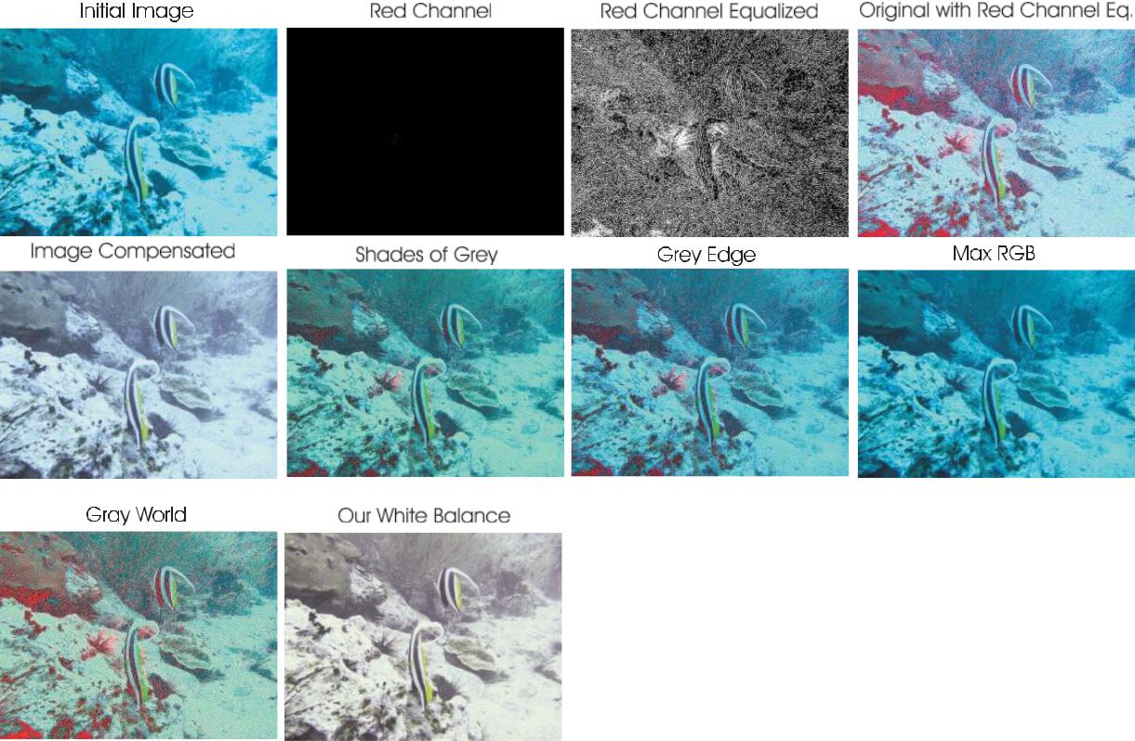As depicted in Fig. 1, our image enhancement approach adopts a two step strategy, combining white balancing and image fusion, to improve underwater images without resorting to the explicit inversion of the optical model. In our approach, white balancing aims at compensating for the color cast caused by the selective absorption of colors with depth, while image fusion is considered to enhance the edges and details of the scene, to mitigate the loss of contrast resulting from backscattering. The fusion step is detailed in Section IV. We now focus on the white-balancing stage. White-balancing aims at improving the image aspect, primarily by removing the undesired color castings due to various illumination or medium attenuation properties. In underwater, the perception of color is highly correlated with the depth, and an important problem is the green-bluish appearance that needs to be rectified. As the light penetrates the water, the attenuation process affects selectively the wavelength spectrum, thus affecting the intensity and the appearance of a colored surface (see Section II).

Fig. 2. Underwater white-balancing.

**21**

Most of those methods make a specific assumption to estimate the color of the light source, and then achieve color constancy by dividing each color channel by its corresponding normalized light source intensity. Among those methods, the Gray world algorithm [43] assumes that the average reflectance in the scene is achromatic. Hence, the illuminant color distribution is simply estimated by averaging each channel independently. The Max RGB [42] assumes that the maximum response in each channel is caused by a white patch [44], and consequently estimates the color of the light source by employing the maximum response of the different color channels.

In their ‘Shades-of-Grey’ method [41], Finlayson et al. first observe that Max-RGB and Gray-World are two instantiations of the Minkowski p-norm applied to the native pixels, respectively with p = ∞ and p = 1, and propose to extend the process to arbitrary p values. The best results are obtained for p = 6. The Grey-Edge hypothesis of van de Weijer et al. [40] further extends this Minkowski norm framework. It assumes the average edge difference in a scene to be achromatic, and computes the scene illumination color by applying the Minkowski p-norm on the derivative structure of image channels, and not on the zero-order pixel structure, as done in Shades of Grey.

Despite of its computational simplicity, this approach has been shown to obtain comparable results than state-of-the-art color constancy methods, such as the recent method of [45] that relies on natural image statistics. When focusing on underwater scenes, we have found through the comprehensive study presented in Fig. 9 and Table I that the well-known Gray-World [43] algorithm achieves good visual performance for reasonably distorted underwater scenes. However, a deeper investigation dealing with extremely deteriorated underwater scenes (see Fig. 2) reveals that most traditional methods perform poorly. They fail to remove the color shift, and generally look bluish. The methods that best remove the bluish tone is the Grey World, but we observe that this method suffers from severe red artifacts. Those artifacts are due to a very small mean value for the red channel, leading to an overcompensation of this channel in locations where red is present (because Gray world divides

22

To circumvent this issue, following the conclusions of previous underwater works .

we therefore primarily aim to compensate for the loss of the red channel. In a second step, the Gray World algorithm will be adopted to compute the white balanced image.

To compensate for the loss of red channel, we build on the four following observations/principles:

1. The green channel is relatively well preserved under water, compared to the red and blue ones. Light with a long wavelength, i.e. the red light, is indeed lost first when traveling in clear water;
2. The green channel is the one that contains opponent color information compared to the red channel, and it is thus especially important to compensate for the stronger attenuation induced on red, compared to green. Therefore, we compensate the red attenuation by adding a fraction of the green channel to red. We had initially tried to add both a fraction of green and blue to the red but, as can be observed in Fig. 3, using only the information of the green channel allows to better recover the entire color spectrum while maintaining a natural appearance of the background (water regions);

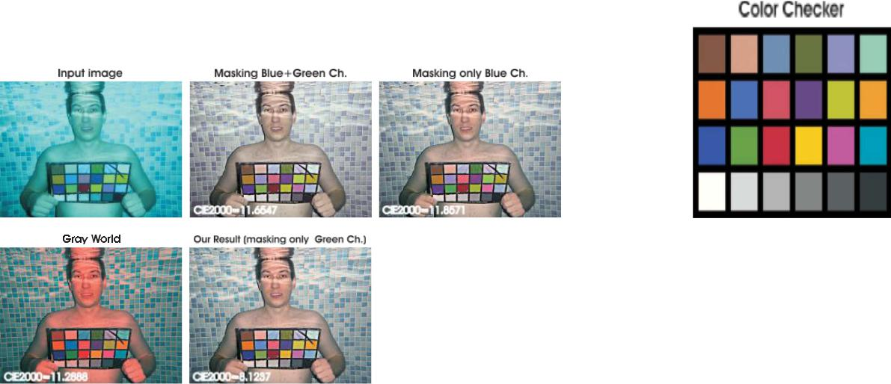

Fig. 3. Compensating the red channel in Equation (4). Since for underwater scenes the blue channel contains most of the details, using this information will reduce the ability to recover certain colors such as yellow and orange and also it tends to transform the blue areas to violet shades. Compensating the red channel by masking only the green channel (Equation (4)) these limitations are reduced significantly. This is confirmed visually but also by computing the CIE2000 measure using as a reference the color checker (displayed with white ink on the resulted images).

23

In other words, the green channel information should not be transferred in regions where the information of the red channel is still significant. Thereby, we want to avoid the reddish appearance introduced by the Gray-World algorithm in the over-exposed regions (see Fig. 3). Basically, the compensation of the red channel has to be performed only in those regions that are highly

attenuated (see Fig. 2). This argument follows the statement in [29], telling that if a pixel has a significant value for the three channels, this is because it lies in a location near the observer, or in an artificially illuminated area, and does not need to be restored.

Mathematically, to account for the above observations, we propose to express the compensated red channel *Irc* at every pixel location *(x)* as follows:

|  |  |
| --- | --- |
| *Irc(x)* = *Ir (x)* + *α.(I*¯*g* − *I*¯*r ).(*1− *Ir (x)).Ig(x),* | (4) |

where *Ir* , *Ig* represent the red and green color channels of image I, each channel being in the interval [0, 1], after normalization by the upper limit of their; dynamic range;

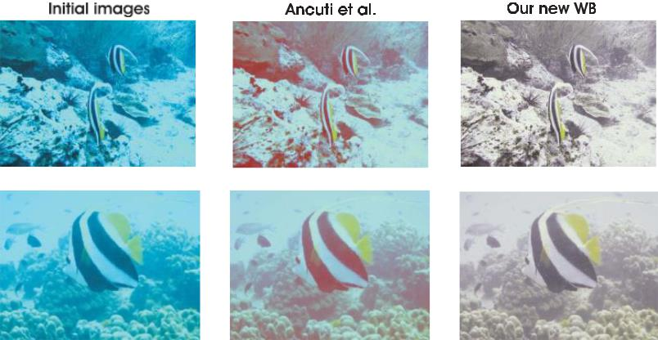

Fig. 4. Comparison to our previous white balancing approach [35].

while ¯Ir and ¯Ig denote the mean value of Ir and Ig. In Equation 4, each factor in the second term directly results from one of the above observations, and α denotes a constant parameter.

24

In practice, our tests have revealed that a value of α = 1 is appropriate for various illumination conditions and acquisition settings. To complete our discussion about the severe and colordependent attenuation of light under water, it is worth noting the works in [31] and

which reveal and exploit the fact that, in turbid waters or in places with high concentration of plankton, the blue channel may be significantly attenuated due to absorption by organic matter. To address those cases, when blue is strongly attenuated and the compensation of the red channel appears to be insufficient, we propose to also compensate for the blue channel attenuation, i.e. we compute the compensated blue channel Ibc as: Ibc(x) = Ib(x) + α.( ¯Ig − ¯Ib).(1 − Ib(x)).Ig(x), (5) where Ib, Ig represent the blue and green color channels of image I, and α is also set to one. In the rest of the paper, the blue compensation is only considered in Figure 14. All other results are derived based on the sole red compensation. After the red (and optionally the blue) channel attenuation has been compensated, we resort to the conventional Gray-World assumption to estimate and compensate the illuminant color cast.

2, our white-balancing approach reduces the quantization artifacts introduced by domain stretching (the red regions in the different outputs). The reddish appearance of high intensity regions is also well corrected since the red channel is better balanced. As will be extensively discussed in Section V-A, our approach shows the highest robustness compared to the other well-known white-balancing techniques.

In particular, whilst being conceptually simplest, we observe in Fig. 4 that, in cases for which the red channel of the underwater image is highly attenuated, it outperforms the white balancing strategy introduced in our conference version of our fusion-based underwater dehazing method

[35].

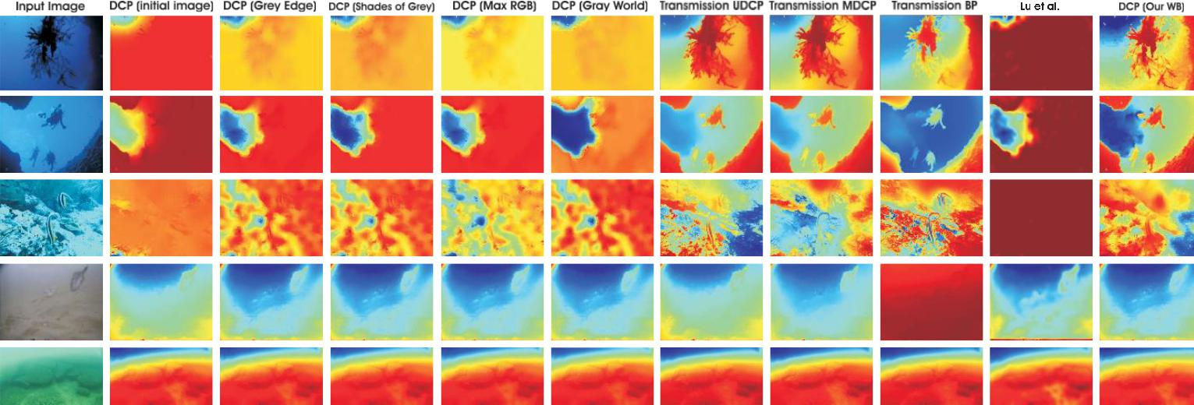

Fig. 5. Underwater transmission estimation. Columns 2 to 6, the transmission map is estimated based on DCP [26]

25

Additionally, Fig. 5 shows that using our white balancing strategy yields significant improvement in estimating transmission based on the well-known DCP [26]. As can be seen in the first seven columns of Fig. 5, estimating the transmission maps based on DCP, using the initial underwater images but also the processed versions with several well-known white balancing approaches (Gray Edge [40], Shades of Gray [41], Max RGB [42] and Gray World [43]) yields poor estimates.

In contrast, by simply applying DCP on our white balanced image version we obtain comparable and even better estimates than the specialized underwater techniques of UDCP [49], MDCP [50] and BP [51]. Despite white balancing is crucial to recover the color, using this correction step is not sufficient to solve the dehazing problem since the edges and details of the scene have been affected by the scattering.

**26**

**3.2 Multi-Scale Fusion**

In this work we built on the multi-scale fusion principles to propose a single image underwater dehazing solution. Image fusion has shown utility in several applications such as image compositing [52], multispectral video enhancement [53], defogging [23], [54] and HDR imaging [55]. Here, we aim for a simple and fast approach that is able to increase the scene visibility in a wide range of underwater videos and images. Similar to [23] and [54], our framework builds on a set of inputs and weight maps derived from a single original image. In contrast to [23] and [54] however, those ones are specifically chosen in order to take the best out of the white-balancing method introduced in the previous section. In particular, as depicted in Fig.1, a pair of inputs is introduced to respectively enhance the color contrast and the edge sharpness of the white-balanced image, and the weight maps are defined to preserve the qualities and reject the defaults of those inputs, i.e. to overcome the artifacts induced by the light propagation limitation in underwater medium. This multi-scale fusion significantly differs from our previous fusion-based underwater dehazing approach published at IEEE CVPR . To derive the inputs from the original image, our initial CVPR algorithm did assume that the backscattering component (due to the artificial light that hits the water particles and is then reflected back to the camera) has a reduced influence. This assumption is generally valid for underwater scenes decently illuminated by natural light, but fails in more challenging illumination scenarios , as revealed by Fig. 11 in the results section. In contrast, this paper does not rely on the optical model and proposes an alternative definition of inputs and weights to deal with severely degraded scenes.

As depicted in Fig. 8 and detailed below, our underwater dehazing technique consists in three main steps: inputs derivation from the white balanced underwater image, weight maps definition, and multi-scale fusion of the inputs and weight maps.

**Inputs of the Fusion Process**

Since the color correction is critical in underwater, we first apply our white balancing technique to the original image. This step aims at enhancing the image appearance by discarding unwanted color casts caused by various illuminants. In water deeper than 30 ft, white balancing suffers from noticeable effects since the absorbed colors are difficult to be recovered.

27

As a result, to obtain our first input we perform a gamma correction of the white balanced image version. Gamma correction aims at correcting the global contrast and is relevant since, in general, white balanced underwater images tend to appear too bright. This correction increases the difference between darker/lighter regions at the cost of a loss of details in the under-/over-exposed regions. To compensate for this loss, we derive a second input that corresponds to a sharpened version of the white balanced image. Therefore, we follow the unsharp masking principle, in the sense that we blend a blurred or unsharp (here Gaussian filtered) version of the image with the image to sharpen.

The typical formula for unsharp masking defines the sharpened image S as

S = I + β(I − G ∗ I), where I is the image to sharpen (in our case the white balanced image), G ∗ I denotes the Gaussian filtered version of I, and β is a parameter. In practice, the selection of β is not trivial. A small β fails to sharpen I, but a too large β results in over-saturated regions, with brighter highlights and darker shadows.

To circumvent this problem,we define the sharpened image S as follows: S = (I + N {I − G ∗ I}) /2, (6) with N {.} denoting the linear normalization operator, also named histogram stretching in the literature. This operator shifts and scales all the color pixel intensities of an image with a unique shifting and scaling factor defined so that the set of transformed pixel values cover the entire available dynamic range.

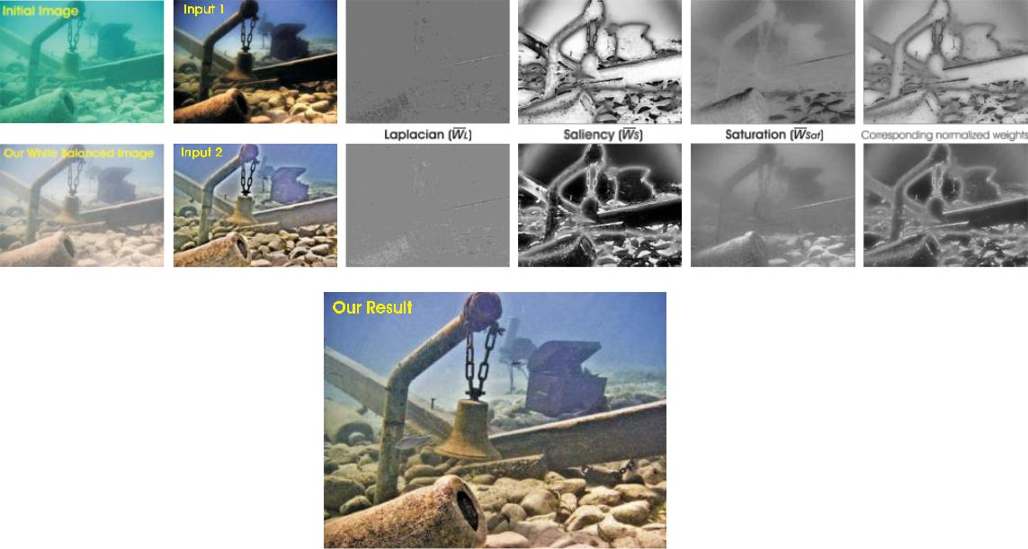

Fig. 6. The two inputs derived from our white balanced image version, the three corresponding normalized weight maps for each of them, the corresponding normalized weight maps and our final result.

28

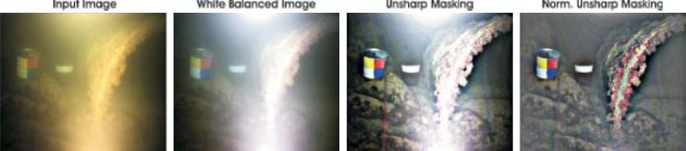

Fig. 7. Comparison between traditional unsharp masking and normalized unsharp masking applied on the white balanced image.

The sharpening method defined in (6) is referred to as normalized unsharp masking process in the following. It has the advantage to not require any parameter tuning, and appears to be effective in terms of sharpening (see examples in Fig. 7). This second input primarily helps in reducing the degradation caused by scattering.

Since the difference between white balanced image and its Gaussian filtered version is a high pass signal that approximates the opposite of Laplacian, this operation has the inconvenient to magnify the high frequency noise, thereby generating undesired artifacts in the second input [56]. The multi-scale fusion strategy described in the next section will be in charge of minimizing the transfer of those artifacts to the final blended image.

**Weights of the Fusion Process**

The weight maps are used during blending in such a way that pixels with a high weight value are more represented in the final image (see Fig. 6). They are thus defined based on a number of local image quality or saliency metrics.

Laplacian contrast weight (WL ) estimates the global contrast by computing the absolute value of a Laplacian filter applied on each input luminance channel. This straightforward indicator was used in different applications such as tone mapping [55] and extending depth of field [57] since it assigns high values to edges and texture. For the underwater dehazing task, however, this weight is not sufficient to recover the contrast, mainly because it can not distinguish much between a ramp and flat regions. To handle this problem, we introduce an additional and complementary contrast assessment metric.

29

Saliency weight (WS) aims at emphasizing the salient objects that lose their prominence in the underwater scene. To measure the saliency level, we have employed the saliency estimator of Achantay et al. [58]. This computationally efficient algorithm has been inspired by the biological concept of center-surround contrast. However, the saliency map tends to favor highlighted areas (regions with high luminance values). To overcome this limitation, we introduce an additional weight map based on the observation that saturation decreases in the highlighted regions.

Saturation weight (WSat) enables the fusion algorithm to adapt to chromatic information by advantaging highly saturated regions. This weight map is simply computed (for each input Ik ) as the deviation (for every pixel location) between the Rk ,Gk and Bk color channels and the luminance Lk of the kth input:

WSat = 1/3 sqrt( (Rk −Lk)2+(Gk−Lk)2+(Bk−Lk )2 ) (7)

In practice, for each input, the three weight maps are merged in a single weight map as follows. For each input k, an aggregated weight map Wk is first obtained by summing up the three WL , WS, and WSat weight maps. The K aggregated maps are then normalized on a pixel-per-pixel basis, by dividing the weight of each pixel in each map by the sum of the weights of the same pixel over all maps. Formally, the normalized weight maps W¯k are computed for each input as W¯k = (Wk + δ)/(K k=1 Wk + K.δ), with δ denoting a small regularization term that ensures that each input contributes to the output. δ is set to 0.1 in the rest of the paper. The normalized weights of corresponding weights are shown at the bottom of Fig. 6.

Note that, in comparison with our previous work [35], we limit ourselves to these three weight maps only, and we do not compute the exposedness weight map anymore. In addition to reducing the overall complexity of the fusion process, we have observed that, when using the two inputs proposed in this paper, the exposedness weight map tends to amplify some artifacts, such as ramp edges of our second input, and to reduce the benefit derived from the gamma corrected image in terms of image contrast. We explain this observation as follows. Originally, in an exposure fusion context [55], the exposedness weight map had been introduced to reduce the weight of pixels that are under- or over-exposed.

30

Hence, this weight map assigns large (small) weight to input pixels that are close to (far from) the middle of the image dynamic range. In our case, since the gamma corrected input tends to exploit the whole dynamic range, the use of the exposedness weight map tends to penalize it in favor of the sharpened image, thereby inducing some sharpening artifacts and missing some contrast enhancements.

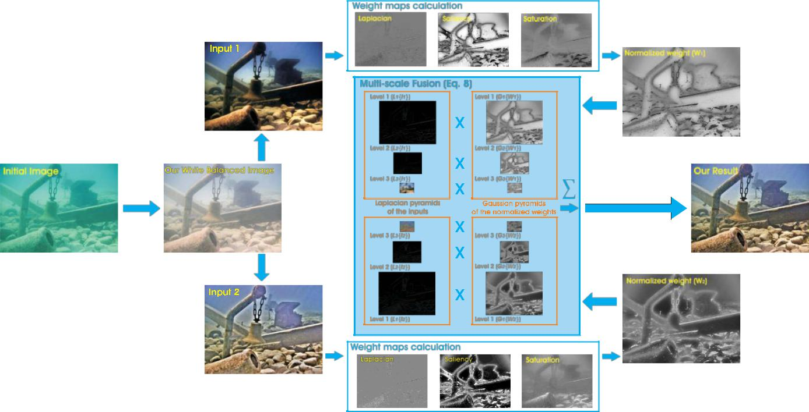

Fig. 8. Overview of our dehazing scheme.

**Naive Fusion Process**

Given the normalized weight maps, the reconstructed image R(x) could typically be obtained by fusing the defined inputs with the weight measures at every pixel location (x): R(x) = K k=1 W¯k (x)Ik (x) (8) where Ik denotes the input (k is the index of the inputs - K = 2 in our case) that is weighted by the normalized weight maps W¯k . In practice, the naive approach introduces undesirable halos [35]. A common solution to overcome this limitation is to employ multi-scale linear [57], [59] or non-linear filters [60], [61].

**31**

**Multi-Scale Fusion Process**

The multi-scale decomposition is based on Laplacian pyramid originally described in Burt and Adelson [57]. The pyramid representation decomposes an image into a sum of bandpass images.

In practice, each level of the pyramid does filter the input image using a low-pass Gaussian kernel G, and decimates the filtered image by a factor of 2 in both directions.

It then subtracts from the input an up-sampled version of the low-pass image, thereby approximating the (inverse of the) Laplacian, and uses the decimated low-pass image as the input for the subsequent level of the pyramid. Formally, using Gl to denote a sequence of l low-pass filtering and decimation, followed by l up-sampling operations, we define the N levels Ll of the pyramid as follows:

I(x) = I(x)−G1 {I(x)}+G1 {I(x)} L1 {I(x)}+G1 {I(x)}

* + L1 {I(x)}+G1 {I(x)}−G2 {I(x)}+G2 {I(x)}
* L1 {I(x)}+L2 {I(x)}+G2 {I(x)}
* ...
* sigma( N l=1 Ll {I(x)})

In this equation, Ll and Gl represent the l th level of the Laplacian and Gaussian pyramid, respectively. To write the equation, all those images have been up-sampled to the original image dimension. However, in an efficient implementation, each level l of the pyramid is manipulated at native subsampled resolution.

Following the traditional multi-scale fusion strategy [55], each source input Ik is decomposed into a Laplacian pyramid [57] while the normalized weight maps W¯ k are decomposed using a Gaussian pyramid.

32

Both pyramids have the same number of levels, and the mixing of the Laplacian inputs with the Gaussian normalized weights is performed independently at each level l:

Rl(x) = sigma( K k=1 Gl W¯ k (x) Ll {Ik (x)}) (10)

where l denotes the pyramid levels and k refers to the number of input images. In practice, the number of levels N depends on the image size, and has a direct impact on the visual quality of the blended image. The dehazed output is obtained by summing the fused contribution of all levels, after appropriate upsampling.

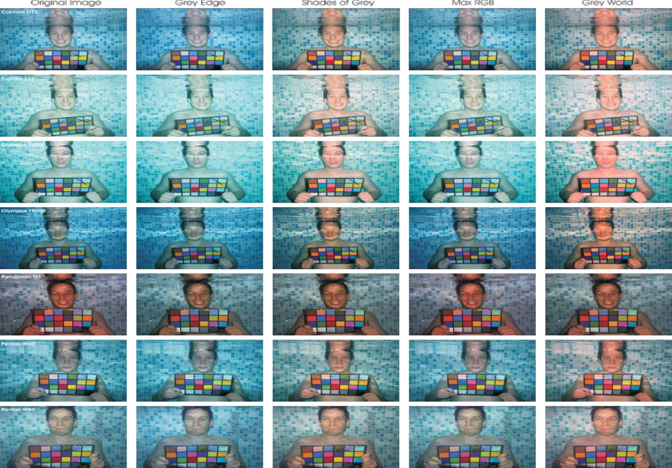

Fig. 9. Comparative results of different white balancing techniques. From left to right: 1. Original underwater images taken with different cameras; 2. Gray Edge [40]; 3. Shades of Gray [41]; 4. Max RGB [42]; 5. Gray World [43]; 6. Our previous white balancing technique [35]; 7. Our new white balancing technique. The cameras used to take the pictures are Canon D10, Fuji

33

**TABLE I**

**WHITE BALANCING QUANTITATIVE EVALUATION BASED ON CIEDE2000 AND *Qu* [63] MEASURES**

**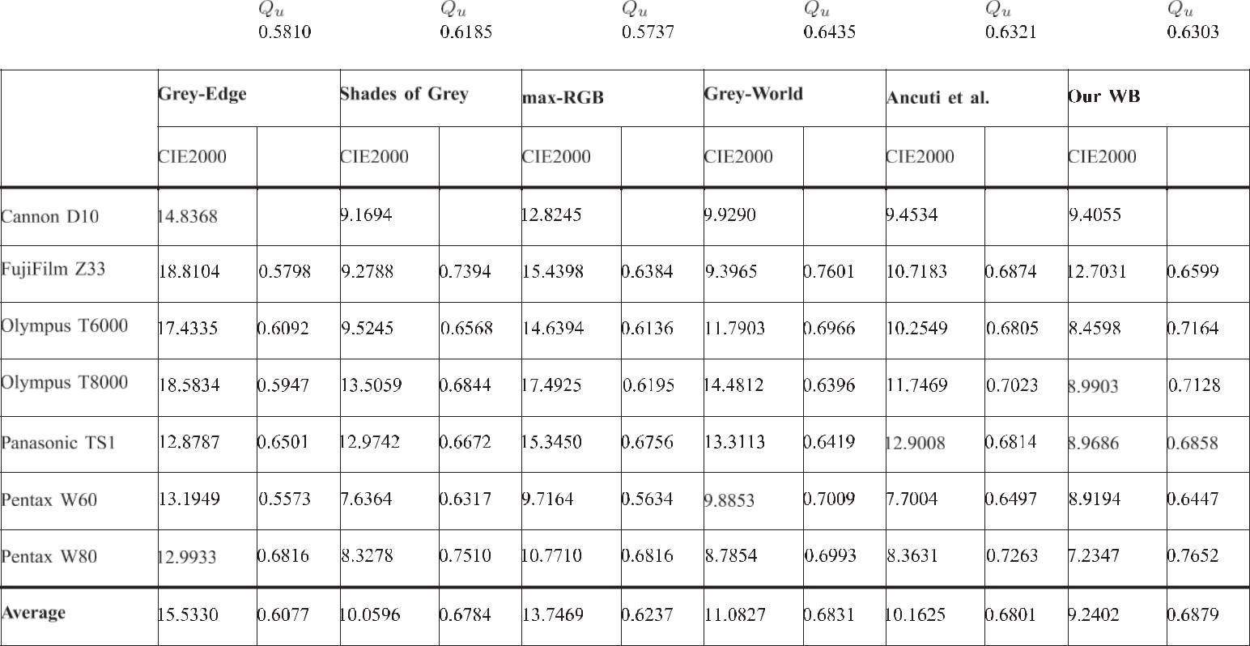**

By independently employing a fusion process at every scale level, the potential artifacts due to the sharp transitions of the weight maps are minimized. Multi-scale fusion is motivated by the human visual system, which is very sensitive to sharp transitions appearing in smooth image patterns, while being much less sensitive to variations/artifacts occurring on edges and textures (masking phenomenon).

**34**

**3.3 Results and Discussions**

Our approach is a two step process. Majorly White Balancing and Multi-Scale Fusion. The output image of the White Balancing approach is given as input to Gamma Correction and Image Sharpening for further enhancement. Now the two outputs of gamma correction and Image sharpening is given as input to multi-scale fusion process. This process gives the final output of our approach.

**White Balancing-**

White Balancing is the first step in our proposed solution. White Balancing is performed in two steps:

* Loss of Red Channel
* Adoption of Gray World Algorithm

**Loss of Red Channel-**

We compensate the loss of Red channel in underwater images here. This is done by adding a part of green channel to it.

Mathematically, to account for the above observations, we propose to express the compensated red channel *Irc* at every pixel location *(x)* as follows:

|  |
| --- |
| **Irc(x) = Ir (x) + α.(I¯g − I¯r ).(1−Ir(x)).Ig(x),** |

where *Ir* , *Ig* represent the red and green color channels of image I, each channel being in the interval [0, 1], after normalization by the upper limit of their dynamic range.

35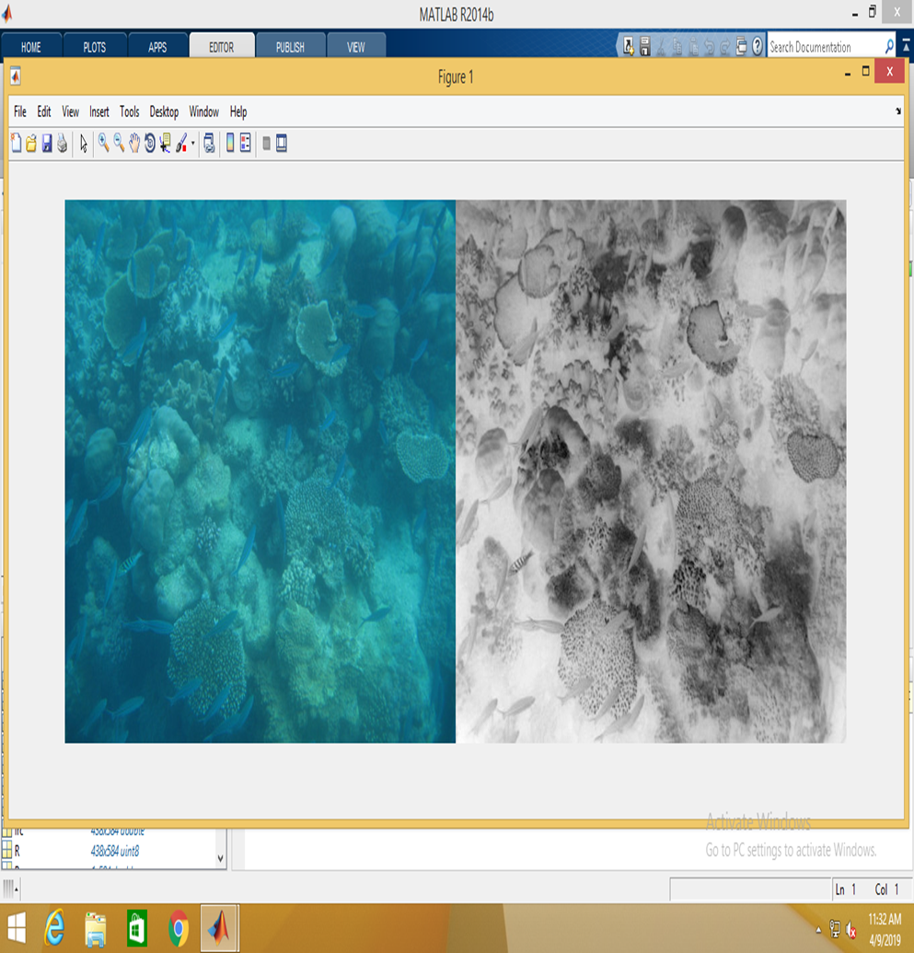

The above image shows the input image and the image generated after compensating the loss of red channel.

**Gray World Algorithm-**

The output of the compensation of loss of red channel is given as input to the gray world algorithm. This produces an enhanced image of the original image.

Gray world algorithm produces an estimate of illumination by computing the mean of each channel of the image.

One of the methods of normalization is that the mean of the three components is used as illumination estimate of the image. To normalize the image of channel i ,the pixel value is scaled by Image 1 for Color Constancy: Gray World Algorithm where Image 2 for Color Constancy: Gray World Algorithm is the channel mean and Image 3 for Color Constancy: Gray World Algorithm$ is the illumination estimate .   
 36  
Another method of normalization is normalizing to the maximum channel by scaling by $s\_i$ Image 4 for Color Constancy: Gray World Algorithm   
  
Another method of normalization is normalizing to the maximum channel by scaling by norm $m\_i$ Image 5 for Color Constancy: Gray World Algorithm   
  
Image 6 for Color Constancy: Gray World Algorithm

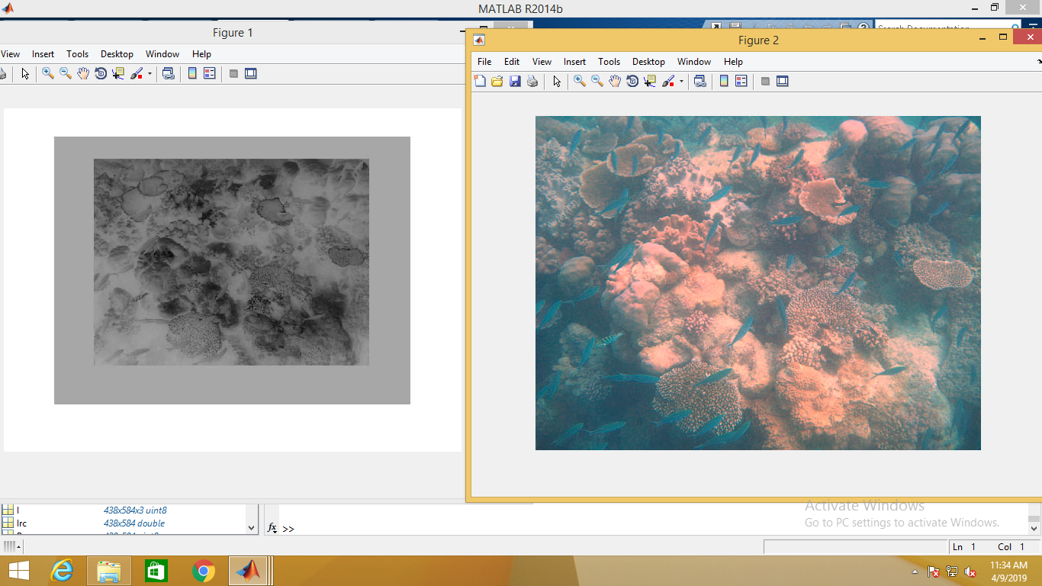

The above image shows the result after the adoption of gray world algorithm.

**37**

**Gamma Correction-**

**Gamma correction**, or often simply **gamma**, is a nonlinear operation used to encode and decode [luminance](https://en.wikipedia.org/wiki/Relative_luminance) or [tristimulus values](https://en.wikipedia.org/wiki/CIE_1931_color_space" \l "Tristimulus_values" \o "CIE 1931 color space) in [video](https://en.wikipedia.org/wiki/Video) or [still image](https://en.wikipedia.org/wiki/Still_image) systems. Gamma correction is, in the simplest cases, defined by the following [power-law](https://en.wikipedia.org/wiki/Power_law) expression:

**{\displaystyle V\_{\text{out}}=A{V\_{\text{in}}^{\gamma }}}VVVvvVout = A \* Vin $^$ ϓ**

Here Vin is raised to the power ϓ Where we specify the ϓ value, and is multiplied to A value to get the output Vout. Where A=1. ϓ is generally in the range of 0-1 .

If ϓ > 1 , we get a darker image.

If ϓ = 1 , We get image as it is.

If ϓ < 1 , we get a brighter image.

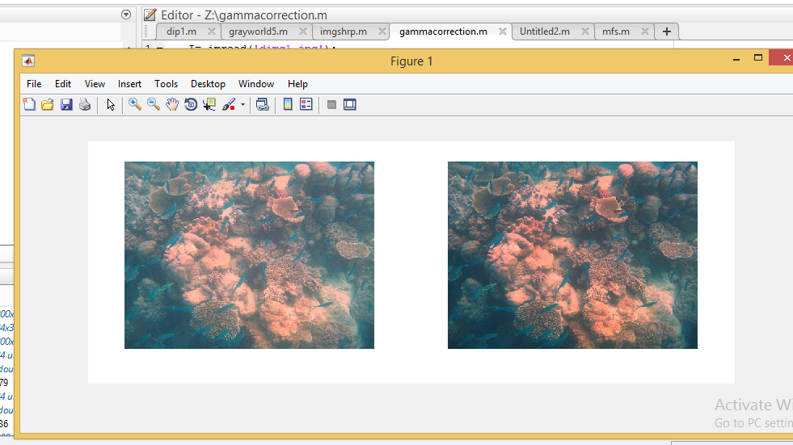

The above image shows the output obtained after gamma correction of an image.

38

**Image Sharpening-**

 The sharpening operation can be represented by

https://nptel.ac.in/courses/117104069/chapter_8/8_32_clip_image002_0004.gif

where https://nptel.ac.in/courses/117104069/chapter_8/8_32_clip_image002_0000.gif is the original pixel value at the coordinatehttps://nptel.ac.in/courses/117104069/chapter_8/8_32_clip_image004.gif is the high-pass filter, https://nptel.ac.in/courses/117104069/chapter_8/8_32_clip_image006.gif is a tuning parameter greater that or equal zero, and  is the sharpened pixel at the coordinate https://nptel.ac.in/courses/117104069/chapter_8/8_32_clip_image010.gif. The value taken by https://nptel.ac.in/courses/117104069/chapter_8/8_32_clip_image006_0000.gif depends on the grade of sharpness desired. Increasing https://nptel.ac.in/courses/117104069/chapter_8/8_32_clip_image006_0001.gif yields a more sharpened image.

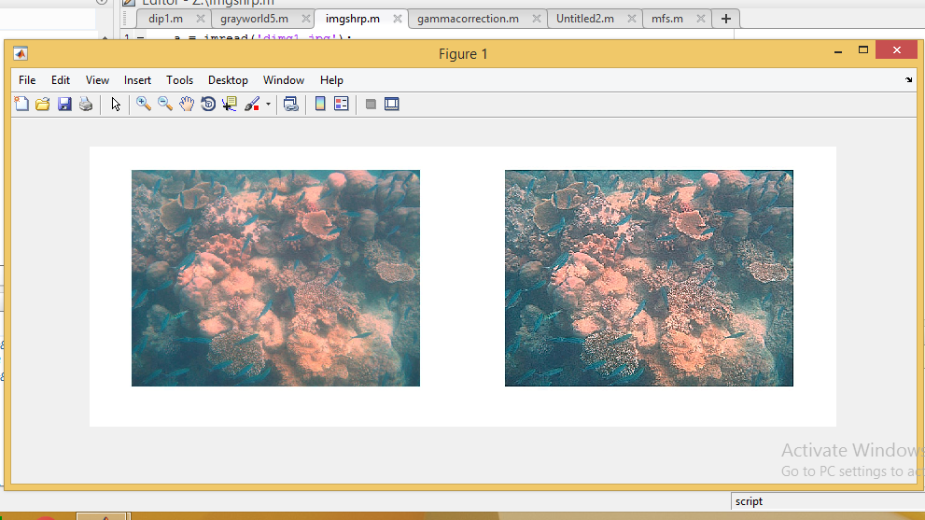

This image shows the output image after sharpening of the input image given i.e, output of gray world algorithm image.

**39**

**Multi-Scale Fusion-**

The traditional multi-scale fusion strategy [55], each source input Ik is decomposed into a Laplacian pyramid [57] while the normalized weight maps W¯ k are decomposed using a Gaussian pyramid. Both pyramids have the same number of levels, and the mixing of the Laplacian inputs with the Gaussian normalized weights is performed independently at each level l:

Rl(x) = sigma( K k=1 Gl W¯ k (x) Ll {Ik (x)})

where l denotes the pyramid levels and k refers to the number of input images. In practice, the number of levels N depends on the image size, and has a direct impact on the visual quality of the blended image. The dehazed output is obtained by summing the fused contribution of all levels, after appropriate upsampling.

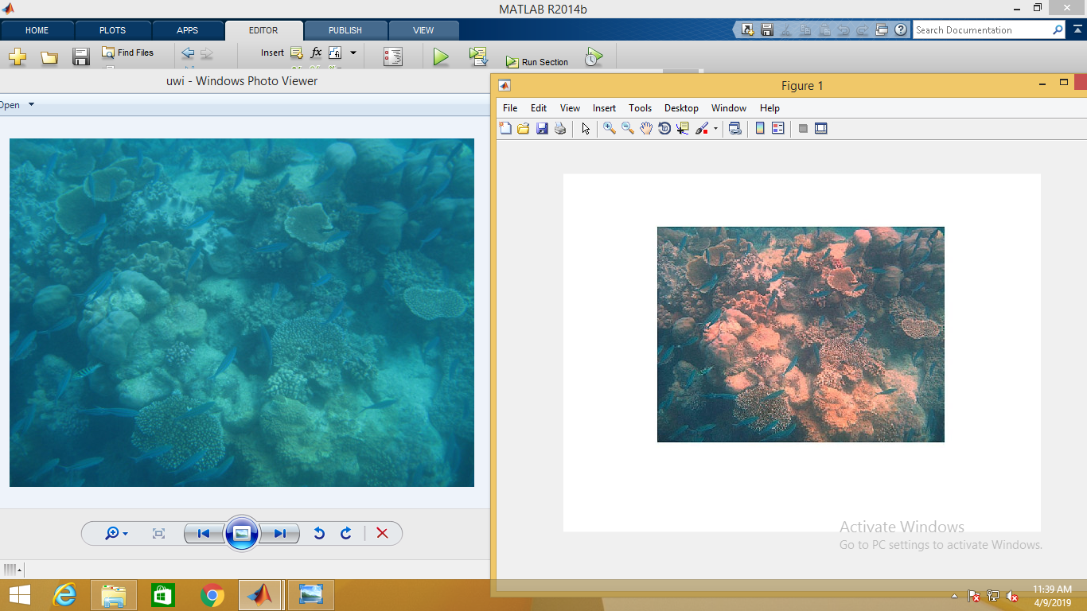

Final output : Input Image and Enhanced Image

40

**CHAPTER-4**

**COMPARISON WITH EXISTING METHODS**

**Underwater White Balancing Evaluation**

Since in general the color is captured differently by various cameras, we first demonstrate that our white balancing approach described in Section III is robust to the camera settings. Therefore, we have processed a set of underwater images that contain the standard Macbeth Color Checker taken by seven different professional cameras (see Fig. 9), namely Canon D10, FujiFilm Z33, Olympus Tough 6000, Olympus Tough 8000, Pentax W60, Pentax W80, Panasonic TS1. All the images have been taken approximately one meter away from the subject. The cameras have been set to their widest zoom setting, except for the Pentax W60, which was set to approximately 35mm. Due to the illumination conditions, flash was used on all cameras. On this set of images, we applied the following methods: the classical white-patch max RGB algorithm [42], the Gray-World [43], but also the more recent Shades-of-Grey [41] and Gray-Edge

1. We compare those methods with our proposed white-balancing strategy in Fig. 9.

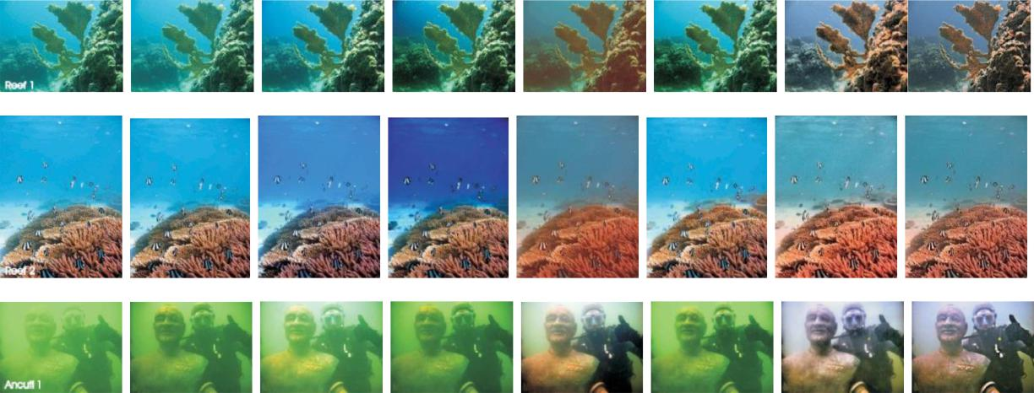

Fig. 10. Comparison to different outdoor and underwater dehazing approaches

41

To analyse the robustness of white balancing, we measure the dissimilarity in terms of color difference between the reference ground truth Macbeth Color Checker and the corresponding color patch, manually located in each image.

Color differences are better represented in the perceptual CIEL∗a∗b∗ color space, where L∗ is the luminance, a∗ is the color on a green-red scale and b∗ is the color on a blue-yellow scale. Relative perceptual differences between any two colors in CIEL∗a∗b∗ can be approximated by employing measures such as CIE76 and CIE94 that basically compute the Euclidean distance between them. A more complex, yet more accurate, color difference measure, which solves the perceptual uniformity issue of CIE76 and CIE94, is CIEDE2000 [68], [69].

CIEDE2000 yields values in the range [0,100], with smaller values indicating small color difference, and values less than 1 corresponding to visually imperceptible differences. Additionally, our assessment considers the index Qu [63] that combines the benefits of SSIM index [70] and Euclidean color distance.

42

**TABLE II**

**UNDERWATER DEHAZING EVALUATION BASED ON PCQI [64], UCIQE [65] AND UIQM [66] METRICS. THE LARGER THE**

**METRIC THE BETTER. THE CORRESPONDING IMAGES (SAME ORDER) ARE PRESENTED IN FIG.10**

**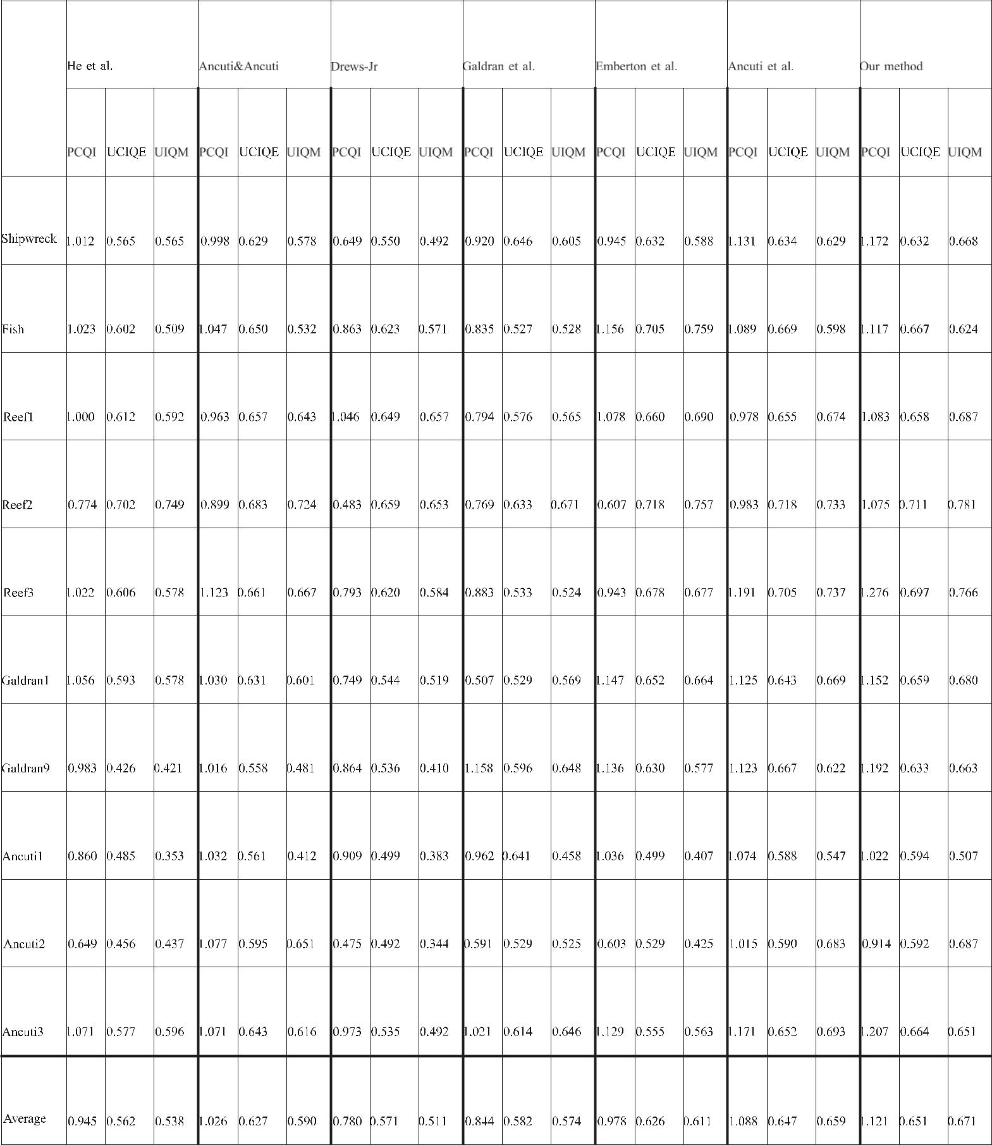**

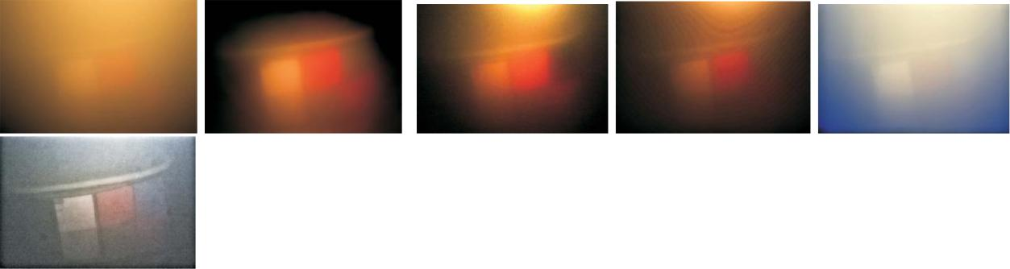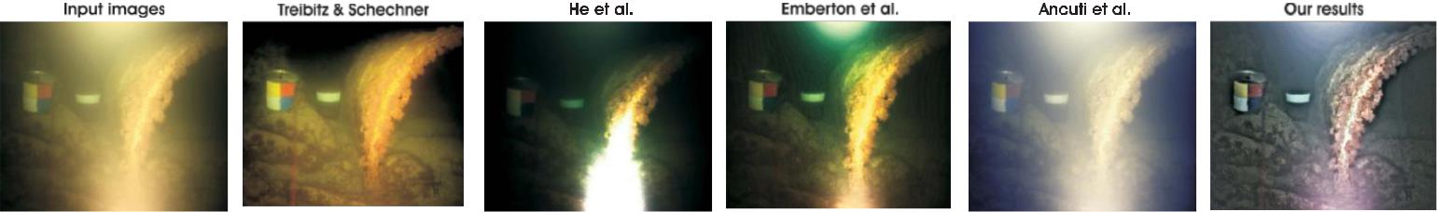

43

Fig. 11. Underwater dehazing of extreme scenes characterized by non-uniform illumination conditions. Our method performs better than earlier approaches of Treibitz and Schechner [67], He *et al.* [19], Emberton *et al.* [30] and Ancuti *et al.* [35].

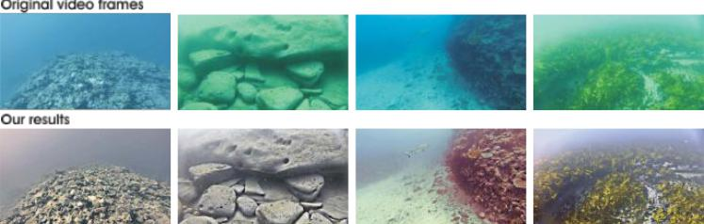

Fig. 12. Underwater video dehazing

Table I shows the quantitative results obtained with the CIEDE2000 metric and index Qu. As can be seen, these professional underwater cameras introduce various color casts, and max RGB and Grey-Edge methods are not able to remove entirely these casts.

44

**Underwater Dehazing Evaluation**

The proposed strategy was tested for real underwater image and videos taken from different available amateur and professional photographer collections, captured using various cameras and setups. Note that we process only 8-bit data format, making our validation relevant for common low-end cameras. For videos, the reader is referred to Fig. 12. Interestingly, our fusion-based algorithm has the advantage to employ only a reduced set of parameters that can be automatically set. Specifically, the white balancing process relies on the single parameter α, which is set to 1 in all our experiments. For the multi-scale fusion, the number of decomposition levels depends on the image size, and is defined so that the size of the smallest resolution reaches a few tenth of pixels (e.g. 7 levels for an 600×800 image size). Fig. 10 presents the results obtained on ten underwater images, by several recent (underwater) dehazing approaches. Table

1. provides the associated quantitative evaluation, using three recent metrics: PCQI [64], UCIQE [65], and UIQM [66]. While PCQI is a general-purpose image contrast metric, the UCIQE and UIQM metrics are dedicated to underwater image assessment. UCIQE metric was designed specifically to quantify the nonuniform color cast, blurring, and low-contrast that characterize underwater images, while UIQM addresses three important underwater image quality criterions: colorfulness, sharpness and contrast.

As can be observed, the outdoor dehazing approaches of He et al. [19] and Ancuti and Ancuti [23] perform poorly for the underwater scenes. As discussed previously, even though there are clear similarities between light propagation in hazy outdoor and in underwater scenes, the underwater dehazing problem is much more challenging.

44

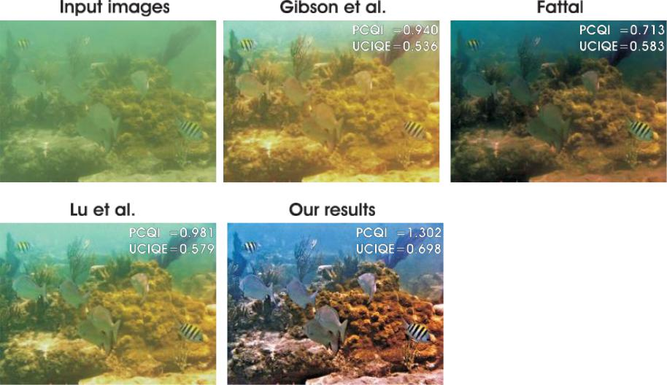

Fig. 13. Comparative results with the recent techniques of Lu *et al.* [31], Fattal [32] and Gisbson *et*

*al.* [50].

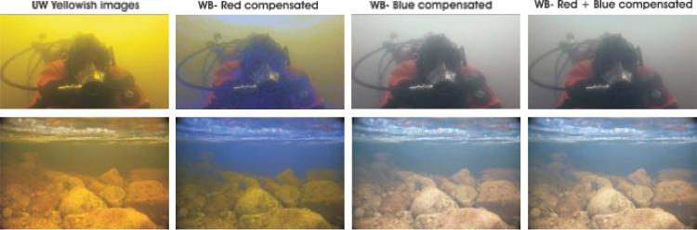

Fig. 14. In turbid water, the blue component is strongly attenuated [31]. Underwater images appear yellowish, and their enhancement requires both red and blue channel compensation, as defined in Equations (4) and (5), respectively.

On the other hand, recent specialized underwater dehazing approaches of Emberton et al. [30] and Galdran et al. [29] show higher robustness than outdoor methods in recovering the visibility of the considered scenes. However, as attested by the last column in Fig. 10, our fusion-based approach

outperforms having similar and in general higher values of the PCQI, UCIQE and UIQM

metrics. Compared with our initial multiscale approach presented in [35], the method introduced in this journal paper is characterized by higher robustness for extreme underwater cases, with turbid sea water and non-uniform artificial illumination.

This is demonstrated by the results shown in Fig. 11 that depict two challenging underwater scenes. As can be seen, the proposed approach is able to perform better than our previous approach both in terms of contrast and color enhancement. Moreover, Fig. 11 presents the results yielded by the polarization technique of Treibitz and Schechner [67], which uses two frames .

45

To complete our visual assessment, Fig. 13 compares our work with the three recent techniques of Lu et al. [31], Fattal [32], and Gisbson et al. [50]. The PCQI and UCIQE metrics are provided for each picture, and are generally better for our approach.

Fig. 14 considers the extreme cases observed in turbid water, where the images appear yellowish due to a strong attenuation of the blue channel. For such images, compensating the red attenuation appears to be insufficient. However, interestingly, we observe that extending the color compensation to the blue component, as defined in Equation (5), significantly improves the enhanced images. Overall, we conclude that our approach generally results in good perceptual quality, with significant enhancement of the global contrast, the color, and the image structure details. The main limitations are related to the fact thatcolor can not always be fully restored, and some haze is maintained, especially in the scene regions that are far from the camera. Those limitations are however limited, especially when compared to previous works. The good performance of our approach is confirmed by the few more examples presented in Fig. 16 and 15. Through this visual assessment, we also observe that, despite the gray-world assumption might obviously not always be strictly valid, the enhanced images derived from our white-balanced image are constantly visually pleasant. It is our belief that the gamma correction involved in the multiscale fusion (see Fig. 1) helps in mitigating the color cast induced by an erroneous gray-world hypothesis. This is for example illustrated in Fig. 6, where input 1-obtained after gamma correction- appears more colorful than second input 2, which corresponds to a sharpened version of the white balanced image.

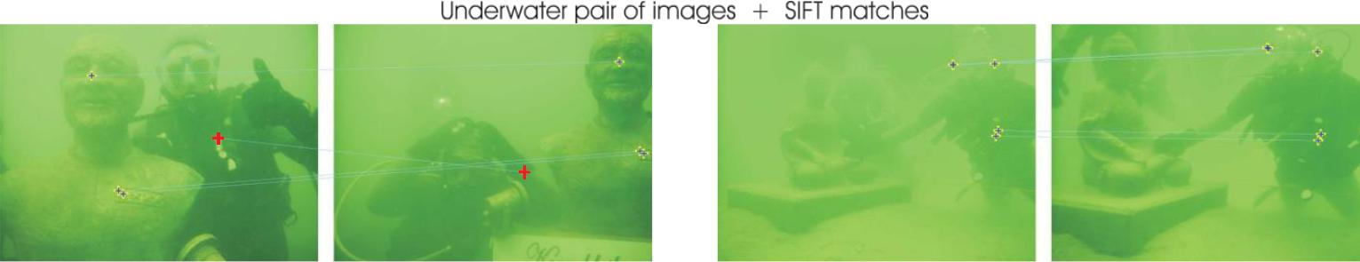

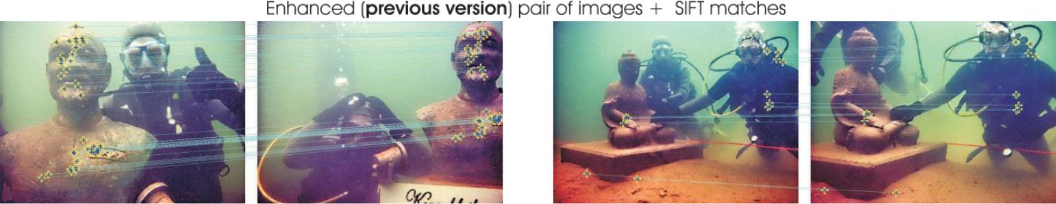

Fig.16. Local feature points matching

46

**CHAPTER-5**

**CONCLUSIONS AND FUTURE WORK**

We have presented an alternative approach to enhance underwater videos and images. Our strategy builds on the fusion principle and does not require additional information than the single original image. We have shown in our experiments that our approach is able to enhance a wide range of underwater images (e.g. different cameras, depths, light conditions) with high accuracy, being able to recover important faded features and edges. Moreover, for the first time, we demonstrate the utility and relevance of the proposed image enhancement technique for several challenging underwater computer vision applications.

**47**

**CHAPTER-6**

**REFERENCES**

1. M. D. Kocak, F. R. Dalgleish, M. F. Caimi, and Y. Y. Schechner, “A focus on recent developments and trends in underwater imaging,” Marine Technol. Soc. J., vol. 42, no. 1, pp.

52–67, 2008.

[2] G. L. Foresti, “Visual inspection of sea bottom structures by an autonomous underwater vehicle,” IEEE Trans. Syst., Man, Cybern. B, Cybern., vol. 31, no. 5, pp. 691–705, Oct. 2001. [3] A. Ortiz, M. Simó, and G. Oliver, “A vision system for an underwater cable tracker,” Mach. Vis. Appl., vol. 13, pp. 129–140, Jul. 2002.

[4] A. Olmos and E. Trucco, “Detecting man-made objects in unconstrained subsea videos,” in Proc. BMVC, Sep. 2002, pp. 1–10.

[5] B. A. Levedahl and L. Silverberg, “Control of underwater vehicles in full unsteady flow,” IEEE J. Ocean. Eng., vol. 34, no. 4, pp. 656–668, Oct. 2009.

* 1. C. H. Mazel, “In situ measurement of reflectance and fluorescence spectra to support hyperspectral remote sensing and marine biology research,” in Proc. IEEE OCEANS, Sep. 2006, pp. 1–4.
  2. Y. Kahanov and J. G. Royal, “Analysis of hull remains of the Dor D Vessel, Tantura

Lagoon, Israel,” Int. J. Nautical Archeol., vol. 30, pp. 257–265, Oct. 2001.

1. R. Schettini and S. Corchs, “Underwater image processing: state of the art of restoration and image enhancement methods,” EURASIP J. Adv. Signal Process., vol. 2010, Dec. 2010, Art. no. 746052.
   1. S. G. Narasimhan and S. K. Nayar, “Contrast restoration of weather degraded images,” IEEE

Trans. Pattern Anal. Mach. Learn., vol. 25, no. 6, pp. 713–724, Jun. 2003.

47

1. D.-M. He and G. G. L. Seet, “Divergent-beam LiDAR imaging in turbid water,” Opt. Lasers
2. Y. Y. Schechner and Y. Averbuch, “Regularized image recovery in scattering media,” IEEE

Trans. Pattern Anal. Mach. Intell., vol. 29, no. 9, pp. 1655–1660, Sep. 2007.

[12] B. L. McGlamery, “A computer model for underwater camera systems,” Proc. SPIE, vol.

208, pp. 221–231, Oct. 1979.

[13] J. S. Jaffe, “Computer modeling and the design of optimal underwater imaging systems,” IEEE J. Ocean. Eng., vol. 15, no. 2, pp. 101–111, Apr. 1990.

1. H. Koschmieder, “Theorie der horizontalen sichtweite,” Beitrage Phys. Freien Atmos., vol. 12, pp. 171–181, 1924.
   1. M. Levoy, B. Chen, V. Vaish, M. Horowitz, I. McDowall, and M. Bolas, “Synthetic aperture confocal imaging,” in Proc. ACM SIGGRAPH, Aug. 2004, pp. 825–834.
   2. S. K. Nayar and S. G. Narasimhan, “Vision in bad weather,” in Proc. IEEE ICCV, Sep.

1999, pp. 820–827.

[17] J. Kopf et al., “Deep photo: Model-based photograph enhancement and viewing,” ACM Trans. Graph., vol. 27, Dec. 2008, Art. no. 116.

1. R. Fattal, “Single image dehazing,” in Proc. ACM SIGGRAPH, Aug. 2008, Art. no. 72.
2. K. He, J. Sun, and X. Tang, “Single image haze removal using dark channel prior,” in Proc.
3. J.-P. Tarel and N. Hautiere, “Fast visibility restoration from a single color or gray level

image,” in Proc. IEEE ICCV, Sep. 2009, pp. 2201–2208.

48

1. J.-P. Tarel, N. Hautiere, L. Caraffa, A. Cord, H. Halmaoui, and D. Gruyer, “Vision enhancement in homogeneous and heterogeneous fog,” IEEE Intell. Transp. Syst. Mag., vol. 4,

no. 2, pp. 6–20, Aug. 2012.

[22] L. Kratz and K. Nishino, “Factorizing scene albedo and depth from a single foggy image,” in Proc. IEEE ICCV, Sep. 2009, pp. 1701–1708.

[23] C. O. Ancuti and C. Ancuti, “Single image dehazing by multi-scale fusion,” IEEE Trans.

Image Process., vol. 22, no. 8, pp. 3271–3282, Aug. 2013.

[24] H. Horvath, “On the applicability of the koschmieder visibility formula,” Atmos. Environ., vol. 5, no. 3, pp. 177–184, Mar. 1971.

[25] C. Ancuti, C. O. Ancuti, C. De Vleeschouwer, and A. Bovik, “Night-time dehazing by fusion,” in Proc. IEEE ICIP, Sep. 2016, pp. 2256–2260.

[26] K. He, J. Sun, and X. Tang, “Single image haze removal using dark channel prior,” IEEE Trans. Pattern Anal. Mach. Intell., vol. 33, no. 12, pp. 2341–2353, Dec. 2011.

1. J. Y. Chiang and Y.-C. Chen, “Underwater image enhancement by wavelength compensation and dehazing,” IEEE Trans. Image Process., vol. 21, no. 4, pp. 1756–1769, Apr. 2012.
   1. P. Drews, Jr., E. Nascimento, F. Moraes, S. Botelho, M. Campos, and R. Grande-Brazil,

“Transmission estimation in underwater single images,” in Proc. IEEE ICCV, Dec. 2013, pp.

825–830.

[29] A. Galdran, D. Pardo, A. Picón, and A. Alvarez-Gila, “Automatic red-channel underwater image restoration,” J. Vis. Commun. Image Represent., vol. 26, pp. 132–145, Jan. 2015.

[30] S. Emberton, L. Chittka, and A. Cavallaro, “Hierarchical rank-based veiling light estimation for underwater dehazing,” in Proc. BMVC, 2015, pp. 125.1–125.12. [31] H. Lu, Y. Li, L. Zhang, and S. Serikawa, “Contrast enhancement for images in turbid water,” J. Opt. Soc. Amer. A, Opt. Image Sci., vol. 32, no. 5, pp. 886–893, May 2015.

49

[32] R. Fattal, “Dehazing using color-lines,” ACM Trans. Graph., vol. 34, Nov. 2014, Art. no.

13.

1. H. Lu, Y. Li, S. Nakashima, H. Kim, and S. Serikawa, “Underwater image super-resolution

by descattering and fusion,” IEEE Access, vol. 5, pp. 670–679, 2017.

* 1. J.-B. Huang, A. Singh, and N. Ahuja, “Single image super-resolution from transformed self-exemplars,” in Proc. IEEE CVPR, Jun. 2015.

1. C. Ancuti, C. O. Ancuti, T. Haber, and P. Bekaert, “Enhancing underwater images and videos by fusion,” in Proc. IEEE CVPR, Jun. 2012, pp. 81–88.
   1. S. Bazeille, I. Quidu, L. Jaulin, and J.-P. Malkasse, “Automatic underwater image pre-

processing,” in Proc. Caracterisation du Milieu Marin (CMM), Brest, France, 2006.

1. A. Arnold-Bos, J.-P. Malkasset, and G. Kervern, “Towards a model-free denoising of

underwater optical images,” in Proc. IEEE Eur. Oceans Conf., Jun. 2005, pp. 527–532.

1. F. Petit, A.-S. Capelle-Laizé, and P. Carre, “Underwater image enhancement by attenuation inversion with quaternions,” in Proc. IEEE ICASSP, Apr. 2009, pp. 1177–1180.
   1. M. Chambah, D. Semani, A. Renouf, P. Courtellemont, and A. Rizzi, “Underwater color

constancy: Enhancement of automatic live fish recognition,” Proc. SPIE, vol. 5293, pp. 157–169, Dec. 2003.

[40] J. van de Weijer, T. Gevers, and A. Gijsenij, “Edge-based color constancy,” IEEE Trans.

Image Process., vol. 16, no. 9, pp. 2207–2214, Sep. 2007.

[41] G. D. Finlayson and E. Trezzi, “Shades of gray and colour constancy,” in Proc. 12th Color Imag. Conf., Color Sci., Syst. Appl., Soc. Imag. Sci. Technol., 2004, pp. 37–41.

50

1. E. H. Land, “The Retinex theory of color vision,” Sci. Amer., vol. 237, no. 6, pp. 108–128, Dec. 1977.
2. G. Buchsbaum, “A spatial processor model for object colour perception,” J. Franklin Inst.,

vol. 310, no. 1, pp. 1–26, Jul. 1980.

1. . Botelho, and M. F. M. Campos, “Underwater depth estimation and image restoration based M. Ebner, Color Constancy, 1st ed. Hoboken, NJ, USA: Wiley, 2007.
2. A. Gijsenij and T. Gevers, “Color constancy using natural image statistics and scene semantics,” IEEE Trans. Pattern Anal. Mach. Intell., vol. 33, no. 4, pp. 687–698, Apr. 2011.
   1. H. Lu et al., “Underwater image enhancement method using weighted guided trigonometric filtering and artificial light correction,” J. Vis. Commun. Image Represent., vol. 38, pp. 504–516, Jul. 2016.

[47] F. Bonin, A. Burguera, and G. Oliver, “Imaging systems for advanced underwater vehicles,” J. Maritime Res., vol. 8, no. 1, pp. 65–86, 2011.

[48] S. Serikawa and H. Lu, “Underwater image dehazing using joint trilateral filter,” Comput.

Elect. Eng., vol. 40, no. 1, pp. 41–50, 2014.

* 1. P. L. J. Drews, Jr., E. R. Nascimento, S. S. Con single images,” IEEE Comput. Graph. Appl., vol. 36, no. 2, pp. 24–35, Mar./Apr. 2016.
  2. K. B. Gibson, D. T. Vo, and T. Q. Nguyen, “An investigation of dehazing effects on image and video coding,” IEEE Trans. Image Process., vol. 21, no. 2, pp. 662–673, Feb. 2012.

1. N. Carlevaris-Bianco, A. Mohan, and R. M. Eustice, “Initial results in underwater single image dehazing,” in Proc. IEEE OCEANS, Sep. 2010, pp. 1–8. [52] M. Grundland, R. Vohra, G.

P. Williams, and N. A. Dodgson, “Cross dissolve without cross fade: Preserving contrast, color

and salience in image compositing,” Comput. Graph. Forum, vol. 25, no. 3, pp. 577–586, 2006.

51

[53] E. P. Bennett, J. L. Mason, and L. McMillan, “Multispectral bilateral video fusion,” IEEE Trans. Image Process., vol. 16, no. 5, pp. 1185–1194, May 2007.

[54] C. O. Ancuti, C. Ancuti, and P. Bekaert, “Effective single image dehazing by fusion,” in Proc. IEEE ICIP, Sep. 2010, pp. 3541–3544.

[55] T. Mertens, J. Kautz, and F. Van Reeth, “Exposure fusion: A simple and practical alternative to high dynamic range photography,” Comput. Graph. Forum, vol. 28, no. 1, pp. 161– 171, 2009.

1. G. C. Rafael and W. E. Richard, Digital Image Processing. Englewood Cliffs, NJ, USA: Prentice-Hall, 2008.
   1. P. Burt and T. Adelson, “The laplacian pyramid as a compact image code,” IEEE Trans.

Commun., vol. COM-31, no. 4, pp. 532–540, Apr. 1983.

1. R. Achantay, S. Hemamiz, F. Estraday, and S. Susstrunk, “Frequencytuned salient region detection,” in Proc. IEEE CVPR, Jun. 2009, pp. 1597–1604.
2. T. Pu and G. Ni, “Contrast-based image fusion using the discrete wavelet transform,” Opt.
3. S. Paris and F. Durand, “A fast approximation of the bilateral filter using a signal processing approach,” Int. J. Comput. Vis., vol. 81, no. 1, pp. 24–52, Jan. 2009.
   1. Z. Farbman, R. Fattal, D. Lischinski, and R. Szeliski, “Edge-preserving decompositions for multi-scale tone and detail manipulation,” in Proc. ACM SIGGRAPH, 2008, Art. no. 67.
4. C. O. Ancuti, C. Ancuti, C. De Vleeschouwer, and A. C. Bovik, “Single-scale fusion: An

effective approach to merging images,” IEEE Trans. Image Process., vol. 26, no. 1, pp. 65–78, Jan. 2017.

52

[63] Y. Li, H. Lu, J. Li, X. Li, Y. Li, and S. Serikawa, “Underwater image de-scattering and classification by deep neural network,” Comput. Electr. Eng., vol. 54, pp. 68–77, Aug. 2016.

1. S. Wang, K. Ma, H. Yeganeh, Z. Wang, and W. Lin, “A patchstructure representation method for quality assessment of contrast changed images,” IEEE Signal Process. Lett., vol. 22,

no. 12, pp. 2387–2390, Dec. 2015.

[65] M. Yang and A. Sowmya, “An underwater color image quality evaluation metric,” IEEE Trans. Image Process., vol. 24, no. 12, pp. 6062–6071, Dec. 2015. [66] K. Panetta, C. Gao, and S. Agaian, “Human-visual-system-inspired underwater image quality measures,” IEEE J. Ocean. Eng., vol. 41, no. 3, pp. 541–551, Jul. 2015.

[67] T. Treibitz and Y. Y. Schechner, “Active polarization descattering,” IEEE Trans. Pattern Anal. Mach. Intell., vol. 31, no. 3, pp. 385–399, Mar. 2009.

1. G. Sharma, W. Wu, and E. N. Dalal, “The CIEDE2000 color-difference formula: Implementation notes, supplementary test data, and mathematical observations,” Color Res.
2. S. Westland, C. Ripamonti, and V. Cheung, Computational Colour Science Using MATLAB, 2nd ed. Hoboken, NJ, USA: Wiley, 2005.
3. Z. Wang, A. C. Bovik, H. R. Sheikh, and E. P. Simoncelli, “Image quality assessment: From error visibility to structural similarity,” IEEE Trans. Image Process., vol. 13, no. 4, pp.
4. G. Papandreou and P. Maragos, “Multigrid geometric active contour models,” IEEE Trans.

Image Process., vol. 16, no. 1, pp. 229–240, Jan. 2007.

[72] D. G. Lowe, “Distinctive image features from scale-invariant keypoints,” Int. J. Comput.

Vis., vol. 60, no. 2, pp. 91–110, Nov. 2004.